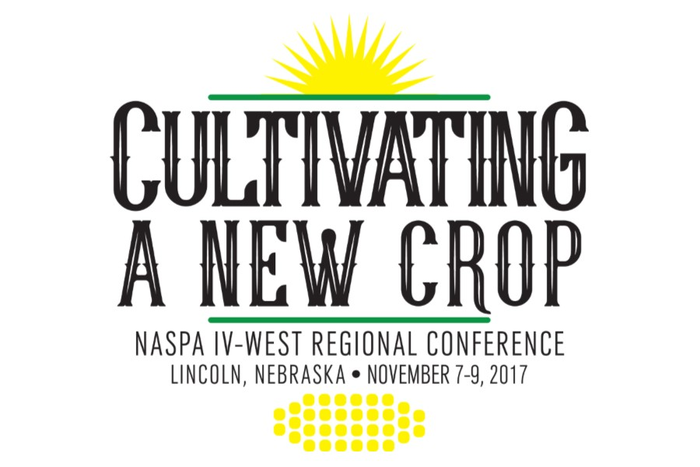
NASPA Regional Conference
Conference Committee Intern(s)
The NASPA Region IV-West Conference Planning Committee is seeking two interns to support conference committee members during the Annual Regional Conference to occur November 6-9 in St. Lincoln, Nebraska.
The intern must be a NASPA Undergraduate Fellows Program participant or graduate student within Region IV-West area at the time of the conference and be available to attend the conference. Although attendance at educational sessions may be limited, interns will gain in-depth exposure to the execution of a large regional conference.
Job duties:
- Participate in conference committee calls from August-October.
- Arrive early at the conference to perform duties as assigned
- Perform a variety of duties at the conference, including but not limited to: assisting with organization logistics, “load-in,” distribution of conference materials, and supplementing the work of on-site volunteers
- Serve as on-site assistance for tasks as assigned by conference committee members
Requirements:

- Excellent written communication skills
- Experience managing logistics and details; skill in organizing large amounts of information
- An interest in engaging with other higher education professionals
- Prior experience in co-curricular event execution, as evidenced through work as a Graduate Assistant, NASPA Undergraduate Fellows Program participant, Resident Assistant/Advisor positions, Student Government Associations, programming boards, student organization, etc.
- Must be a NASPA graduate student member and be attending a graduate school at an institution within the NASPA IV-West Region or an undergraduate NUFP who has attended at least one NASPA Regional or Annual Conference.
Through participation in this internship, a graduate student will have the opportunity to:
- Collaborate with student affairs professionals in the planning, implementation, and execution of a large professional conference
- Participate in conference subcommittees with varying potential responsibilities that may include award/scholarship application review, assisting with various onsite assignments such as registration, volunteer assignments, introduction of featured speakers at the conference, and on-site events and programs
- Connect with student affairs professionals from across the region
The selected intern will receive complimentary registration for the Region IV-West conference and, where possible, shared accommodations at the conference hotel.
Applicants should indicate interest for the position through NASPA’s Volunteer Central website, at https://www.naspa.org/about/get-involved/volunteer , click on “Learn More and Sign Up”, and visit the Region IV-West/East section. Interest is indicated by clicking on the box next to the position you are interested in. Please do so by Friday, July 14. You will receive an email requesting the submission of a resume and completion of an online application once you indicate interest and further follow-up instructions will be provided.

