2017 NASPA Student Affairs Law Conference
Exhibitor & Sponsor Application
December 10 – 12, 2017   New Orleans

Registration Deadline: November 10, 2017
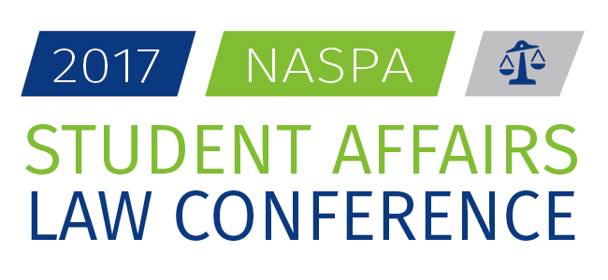
Student affairs professional practice is affected daily by changing laws that require educators to stay at the forefront of a rapidly evolving legal and regulatory landscape. At this conference, expect to gain skills that will build upon your capacity to address pressing legal issues while learning about the most recent trends in higher education law. Join your colleagues to connect your campus' needs with information and approaches to address pressing legal issues in student affairs and higher education. Visit hhttps://www.naspa.org/events/2017Law for more information.

Why become a NASPA Exhibitor/Sponsor Conference?

- Share information about your company or organization with over 100 of our attendees!
- Increase your brand awareness and recognition
- Support our attendees as they come together to discuss higher ed law
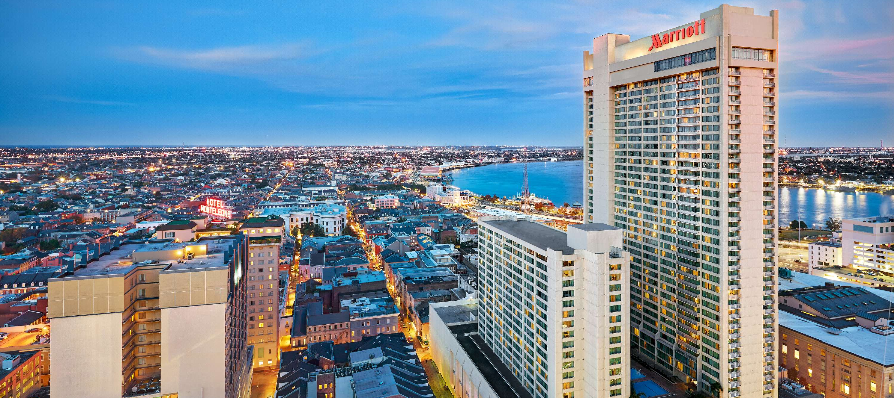
- Build or develop your relationship with NASPA, the premier higher education student affairs association

Join us December 10-12 at the beautiful New Orleans Marriott

Target Attendees:
- AVP or “Number Two”
- Mid-Level
- Senior Level
- Vice President for Student Affairs

Exhibit Packages (Select One or See Sponsor Packages)
Package 1  $1,800  - Exhibit space  - Registration fee for up to three (4)  - Full-page grayscale ad in printed program guide | Package 2  $1,400  - Exhibit space  - Registration fee for up to two (2)  - Full page grayscale ad in printed program guide | Package 3  $1,000  - Exhibit space  - Registration fee for one (1)  - Half-page grayscale ad in printed program guide | Package 4  $900  - Exhibit space  - Registration fee for one (1)
Sponsor Packages (Select One)
Gold Sponsor  $5,000  - Company name, logo and hyperlink recognizing on conference web site.  - Full-page ad program guide.  - Up to four (4) conference registrations included.  - Exhibit table booth opportunity (booth fee included).  - Recognition as a gold conference sponsor in program guide.  - Sign and verbal recognition at the event.  - Eligibility to sponsor a major speaker at the event or speak as a featured speaker (if speaking session needs to be filled)  - Gold level includes sponsorship of opening keynote speaker or awards banquet. |  | Silver Sponsor  $2,500  - Company name, logo and hyperlink recognizing on conference web site.  - Full-page ad program guide.  - Up to two (2) conference registrations included.  - Exhibit table booth opportunity (booth fee included).  - Recognition as a silver conference sponsor in program guide.  - Sign and verbal recognition at the event.  - Silver level includes sponsorship of a special event, such as the senior reception or advisor roundtables.
We also offer customized exhibit/sponsor packages.

All exhibit and sponsorship packages include an exhibit space with: One 8’ table; two chairs; one wastebasket; one program book; a registration mailing list (no e-mail addresses or phone numbers provided).

Program Book Advertising Options

$500 – Program Guide Ad only (600x110 pixels)

Additional Information

REGISTRATION LIST  A registration list is available to all companies participating. The registration list will be emailed two weeks before the conference. Registration mailing lists will be sent in Microsoft Excel format.  Please note that this will be an attendee mailing list only. E-mails and phone numbers of attendees are not included on this list. | PROPERTY RESPONSIBILITY/INSURANCE:  You are responsible for insuring the safety of your personnel and your exhibit materials from theft, damage, accident, fire and other such causes. Exhibitors who desire to carry insurance must do so at their own expense. All property of the exhibitors is understood to remain in their own care, custody and control in transit to and from the confines of the exhibit area, as well as while it is on the floor. Security and storage space will not be provided.  *NASPA and their agents are not responsible for losses incurred, theft or damage to materials
EXHIBITOR INFORMATION:  Thursday, December 10  Opening Reception 5:30 pm – 7:00 pm  (Exhibitors Welcome)  Friday, December 11  Set-up 7:00 am – 7:30 am  Exhibit hours* 7:30 am - 4:00 pm  Continental Breakfast 7:30 am – 8:15 am  Conference Break 12:15 pm – 1:30 pm (lunch on your own)  Exhibitor Teardown** 4:00 pm  * You may choose to remain at your tables during the entire exhibit hours or you may staff it just during the conference breaks and passing periods.  **Exhibitors may not begin dismantling until 4:00pm.  NASPA assumes no responsibility for products left unattended at the end of the conference. | REGISTRATION INFORMATION:  Exhibitor registration and check-in will be at the the JW Marriott New Orleans. Your conference badge is your admission ticket to other conference events and sessions that do not charge special fees. Other individuals who wish to attend the conference will need to register at the appropriate rate.  In-Bound Shipping Instructions  Utilize the correct addressing as noted below to eliminate any package routing delays. All packages received require a release signature and should be captured at the time of package pick-up from hotel associates. In-bound receiving fees will be applied to all packages. Please do not address your packages or packages to the hotel or hotel employees unless specifically directed to do so as this may slow the delivery process.  In-Bound Shipments Address  JW Marriott New Orleans – Conference or Group Name  Guest Name  614 Canal St.  Guest Phone Number  New Orleans, La. 70130

2017 NASPA Student Affairs Law Conference
Organization and Payment Information
Exhibitor & Sponsor Application Deadline is November 1, 2017. No refunds will be given after this date.

Organization Name:
Organization Phone:
Website Address:
Mailing Address:
City, State & Zip code:
Onsite Contact Name/Title: | E-Mail Address:
Onsite Contact Name/Title: | E-Mail Address:
Onsite Contact Name/Title: | E-Mail Address:
Onsite Contact Name/Title: | E-Mail Address:
Onsite Contact Name/Title: | E-Mail Address:
Onsite Contact Name/Title: | E-Mail Address:
Payment type: | Credit card  Check (made payable to NASPA)  Please send to: NASPA; 111 K Street NE, 10th Floor; Washington, DC 20002
Total amount: | $
Cardholder name:
Cardholder address:
Credit card number:
Expiration date:
CVV:
Cardholder signature:
Please submit your application along with a 50 word or less company description by November 1, 2017.
Please fill out the registration form and e-mail to kjerde@naspa.org or fax to 202-204-8443

Next Step
Once we have processed your payment we will send you an email with instructions to register for the conference and other important details.
Thank you for your support!

