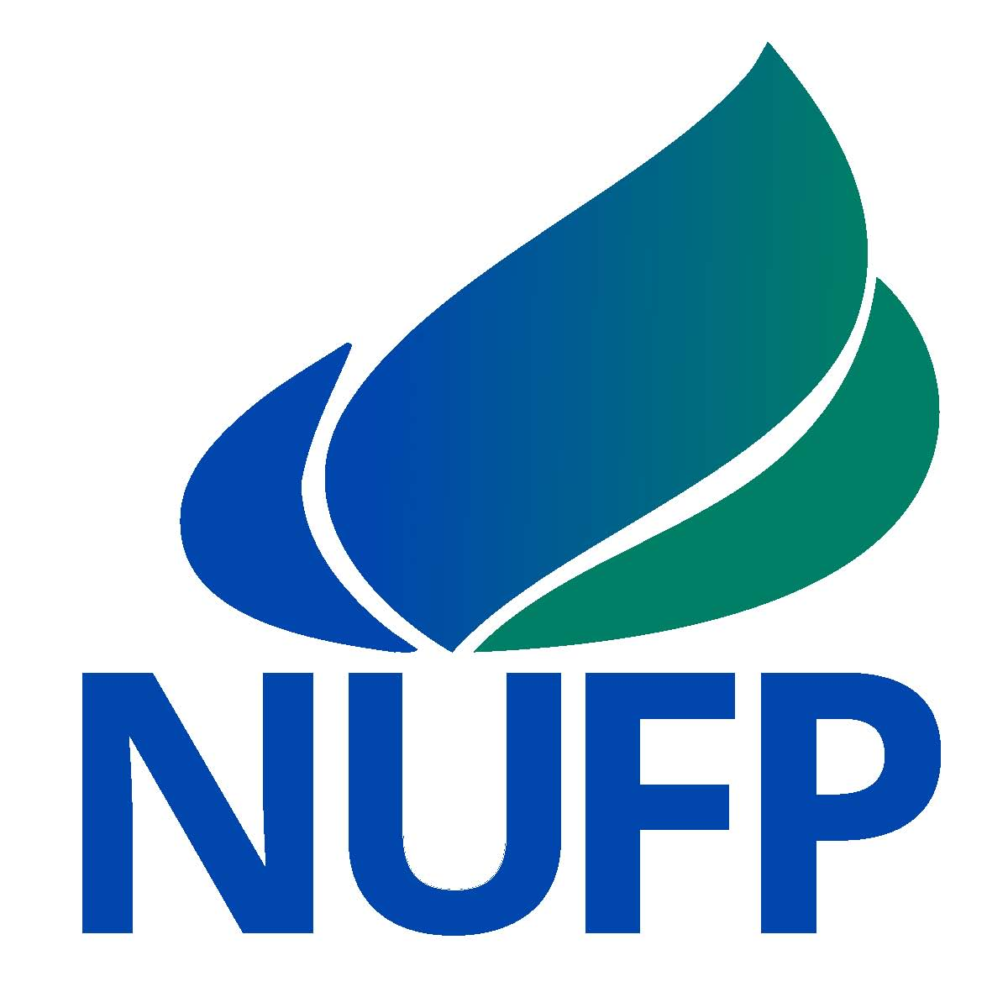 | NUFP Fellow Application Questions  Summer 2019  All supplemental materials must be scanned into one combined PDF and sent to nufp@naspa.org. Individual letters of recommendation must be submitted with the supplemental materials. Your application is not considered complete until you complete the online demographic form at: http://apps.naspa.org/cfp/evt_frm_user.cfm?event_id=1163
- How do you describe student affairs and what aspects of student affairs work appeal to you most as you consider entering the profession?

- Why are you interested in becoming a NUFP Fellow? What goals do you have for participation in the program?

- Selecting one or more of the NUFP program elements, what knowledge or skills do you hope to gain? How will you stay committed and invested in NUFP?

- How have your social identities influenced the way that you’ve experienced college so far?

- Please describe an issue or challenge that you encountered as an undergraduate student. How did you overcome this particular issue and what did you learn from this experience?

- Looking at the application requirements for the program, what else should the selection committee know about you, or your capacity for success in NUFP?

