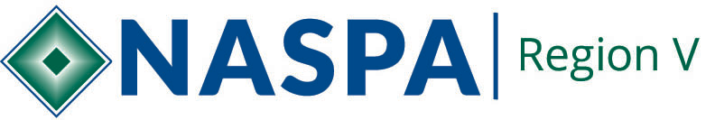

Region V Funding Request Form
Updated October 2018
Thank you for your interest in NASPA Region V sponsorship funding. Use the following template to construct your request. Additional information regarding funding is attached.
Fall 2018 Deadline November 7, 2018 – email to: kgrantham@msubillings.edu

Event or program name:
Requestor name, institution/organization, position:
Requestor phone number and email:
Institution(s) involved:
Please indicate how much you are requesting and from which category of funding:
Innovation Funding:
General Sponsorship Grant:
General Sponsorship Loan:
Total funding requested:
Please attach a detailed budget for the event that includes all sources of funding. If you are requesting a loan be sure to include 3 years of financial history for your program.

Program description
Please provide a brief description of the event that includes your purpose, target audience, and intended outcomes.
How will this event contribute to the Region V Engagement Plan?
How will you recognize NASPA Region V in your program?

Co-Sponsorship Guidelines
The Region V Advisory Board welcomes proposals from Region V members for scholarships and sponsorships. The following guidelines as approved by the Advisory Board apply for funding requests:

Sponsorship
Sponsorship funds are allocated either via reimbursement or as direct payments from Region V. The requestor must provide documentation for all expenses and will be financially responsible for undocumented costs. The requestor will work with the Region V Treasure to access funding.
The Advisory Board will allocate sponsorship funding based on the following objectives:
- Engage and support current NASPA Region V members;
- Outreach to and engage with potential NASPA Region V members;
- Support longstanding partnerships in the Region;
- Opportunity to fund new events and promote emerging competence development among student affairs professionals;
- Sustainable funding practices.

Sponsorship Types
Innovation funding - Funding for new events or expansion of small-scale events with a history of local success. $2,000 has been established in the Region V annual budget for these requests.
$1,000 maximum available per request
Requirements:
- Must be a first-time event or a local event that is being expanded to serve a wider audience.
- Requestor must be a NASPA member or part of a NASPA affiliated institution.
- Requestor must work with a member of the advisory board who can speak on behalf of their proposal.

General Sponsorship Grant - Funding intended to support any event in the region. $4,500 has been established in the Region V annual budget for these requests.
$1,500 maximum available per request
Requirements:
- Requestor must be a NASPA member or part of a NASPA affiliated institution.
- Requestor must work with a member of the advisory board who can speak on behalf of their proposal

General Sponsorship Loan - Funding intended to provide additional capital to events with a proven history of success.
$2,000 has been established in the Region V annual budget for these requests and any allocated funding is encumbered from General Sponsorship Grants until returned.
$1,000 maximum available per request
Requirements and stipulations:
- Requestor must be a NASPA member or part of a NASPA affiliated institution.
- Requests must demonstrate 3 years of success with the same event.
- Requestor must work with a member of the advisory board who can speak on behalf of their proposal.
- Funding must be returned to NASPA Region V within 60 days of the date of the event.
- Institutions/organizations who are unable to return funding are not eligible for NASPA Region V funding for 2 years.

Sponsorship funding cap
$3,000 is the maximum amount of annual funding any single event or program can receive in NASPA Region V funding - including all sponsorships and partnerships with Memberships coordinators and Knowledge Community representatives.

